**AI-Driven Exploration and Prediction of Company Registration Trends with Registrar of companies (RoC)**

**TEAM MEMBER**

**AU620121243057 :**

**VIGNESH.G.A**

**Phase 5 submission Document**

**Project: AI-Driven Exploration and Prediction of Company Registration Trends with Registrar of companies (RoC)**



**Introduction:**

* In today's fast-paced business landscape, the Registrar of Companies (RoC) plays a pivotal role in tracking company registrations. With the advent of Artificial Intelligence (AI), companies are now harnessing its power to gain insights, streamline processes, and predict trends related to RoC registrations. This AI-driven approach revolutionizes how businesses interpret and anticipate company registration data, offering valuable insights for informed decision-making and regulatory compliance. In this discussion, we will delve into the exciting realm of AI-driven explanations and predictions of company registration trends with RoC, exploring its significance and potential impact on various industries.

**Training a model for predicting the success of an AI-driven company using ensemble learning involves several steps:**

1. Data Collection: Gather relevant data about AI-driven companies. This data can include financial metrics, market trends, company size, and more.

2. Data Preprocessing: Clean and preprocess the data, handling missing values, outliers, and standardizing or normalizing features.

3. Feature Selection: Choose the most relevant features that can help in predicting the success of AI-driven companies. This may involve feature engineering as well.

4. Data Split: Split the data into a training set and a testing set to evaluate the model's performance.

5. Model Selection: Choose different machine learning models that can be part of the ensemble. Common choices include decision trees, random forests, gradient boosting, and neural networks.

6. Ensemble Creation: Create an ensemble of models by combining predictions from multiple base models. Common ensemble techniques include bagging (e.g., Random Forests) and boosting (e.g., AdaBoost or Gradient Boosting).

7. Training: Train each base model on the training data.

8. Prediction: Use the trained ensemble to make predictions on the test data.

9. Evaluation: Evaluate the ensemble model's performance using appropriate metrics like accuracy, precision, recall, or F1-score.

10. Hyperparameter Tuning: Optimize the hyperparameters of the individual models and the ensemble to improve performance.

11. Interpretability: Consider interpreting the ensemble model to understand which features are most important for predicting success.

12. Deployment: Once satisfied with the model's performance, deploy it for making predictions on new data.

Keep in mind that building a predictive model for company success is a complex task, and the quality of predictions depends on the data quality and the choice of algorithms. Regular updates and retraining are often necessary to adapt to changing market conditions.

**The data contains 17 columns which are as follows:**

The specific columns or data fields in a company's details can vary depending on the context and the purpose of collecting the information. However, in a typical dataset or database containing company details, you might find the following common data columns:

1. Company Name: The official name of the company.

2. Company ID or Registration Number: A unique identifier for the company.

3. Company Type: The legal structure of the company (e.g., LLC, Corporation, Partnership).

4. Industry or Sector: The industry or sector to which the company belongs (e.g., technology, healthcare, finance).

5. Location: The company's physical address or addresses, including city, state, and country.

6. Contact Information: Contact details for the company, such as phone numbers and email addresses.

7. Founding Date: The date when the company was founded.

8. Company Description: A brief description of the company's mission, products, or services.

9. Financial Data: Information on revenue, profit, assets, and liabilities.

10. Ownership Structure: Details about the ownership of the company, including major shareholders.

11. Leadership Team: Information about key executives and leadership roles within the company.

12. Employee Count: The number of employees working for the company.

13. Website URL: The company's website address.

14. Social Media Links: Links to the company's social media profiles (e.g., LinkedIn, Twitter).

15. Recent News or Updates: Information about recent developments or news related to the company.

16. Partnerships and Alliances: Details about partnerships or collaborations with other organizations.

17. Awards and Recognitions: Any awards or recognitions received by the company.

The specific columns may vary depending on the purpose of the data collection and the industry. For financial analysis, you might find more detailed financial statements, while for marketing purposes, you might focus on customer-related data. It's important to define the data columns based on your specific needs and goals when collecting and organizing company details.

**GIVEN DATASET:**

**Totally we have an 1,50,872 data’s so we take some data’s in our dataset.**

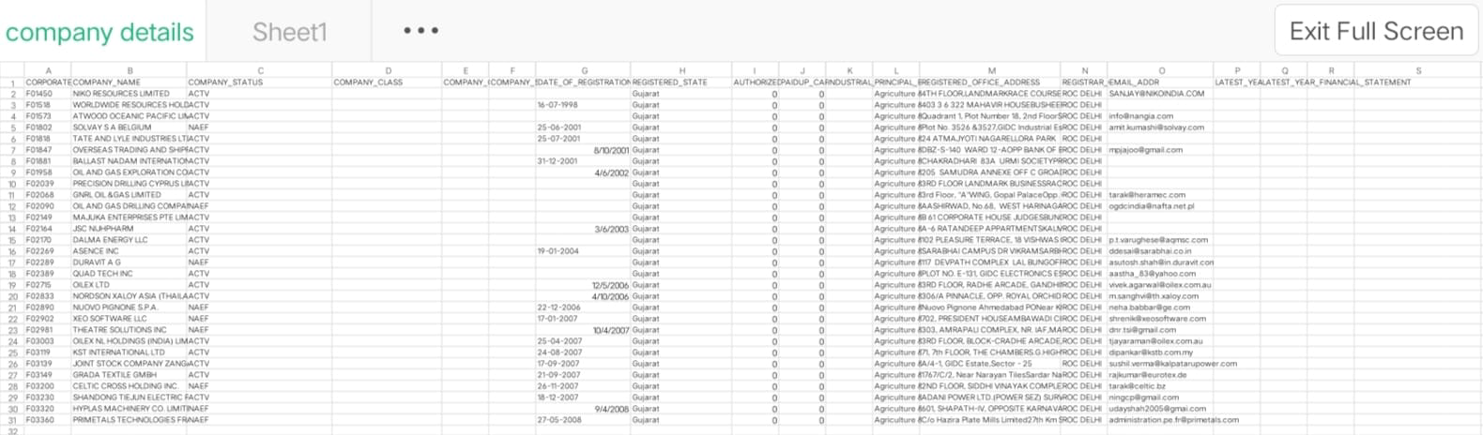

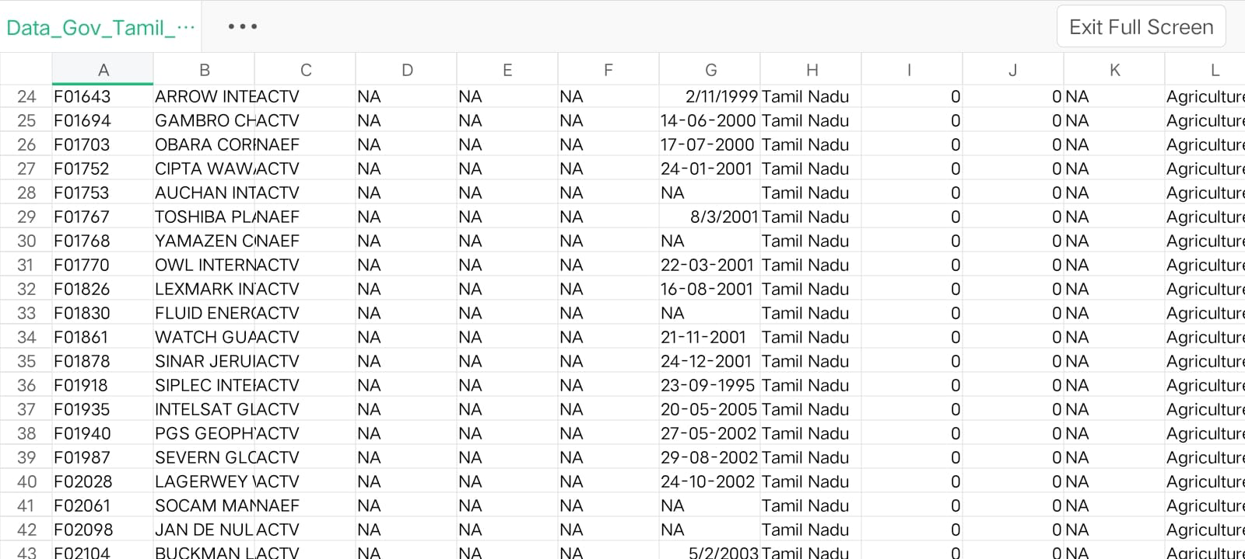

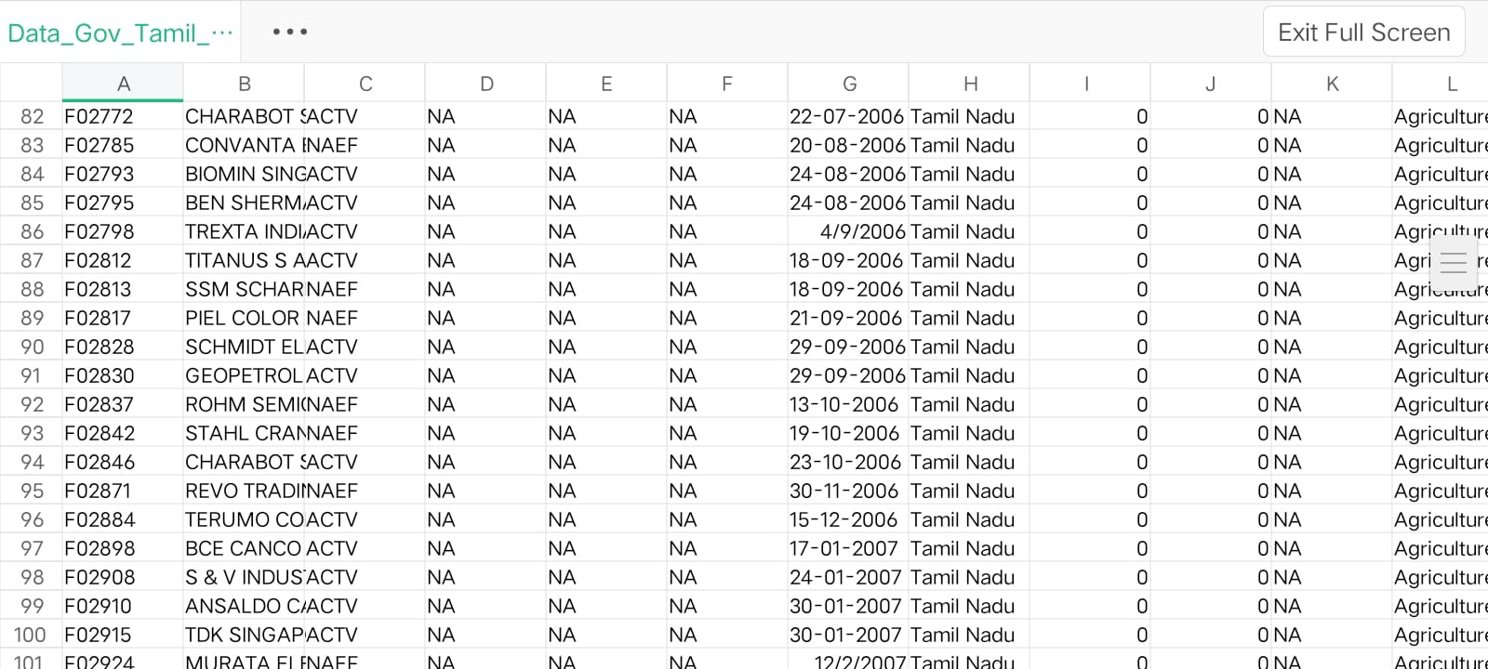

**Necessary step to follow:**

**Import Libraries:**

**Start by importing the necessary libraries:**

**Program:**

import pandas as pd

import numpy as np

from sklearn.model_selection import train_test_split

from sklearn.preprocessing import StandardScaler

**Load the Dataset:**

Load your dataset into a Pandas DataFrame. You can typically find

house price datasets in CSV format, but you can adapt this code to other

formats as needed.

<https://tn.data.gov.in/resource/company-master-data-tamil-nadu-upto-28th-february-2019>

# Load your CSV data into a DataFrame

data = pd.read_csv(‘Data_Gov_Tamil_Nadu.csv’)

# Separate the features (X) and the target variable (y)

X = data.drop('target_column_name', axis=1) # Replace 'target_column_name' with your actual target column

y = data['target_column_name']

**Exploratory Data Analysis (EDA):**

Perform EDA to understand your data better. This includes

checking for missing values, exploring the data's statistics, and

visualizing it to identify patterns

**Program:**

# Check for missing values

print(df.isnull().sum())

# Explore statistics

print(df.describe())

# Visualize the data (e.g., histograms, scatter plots, etc.)

**Feature Engineering:**

Depending on your dataset, you may need to create new features or

transform existing ones. This can involve one-hot encoding categorical

variables, handling date/time data, or scaling numerical features.

# Split the data into training and testing sets

X_train, X_test, y_train, y_test = train_test_split(X, y, test_size=0.2, random_state=42)

# Initialize and train the ensemble model (Random Forest in this example)

ensemble_model = RandomForestClassifier(n_estimators=100, random_state=42)

ensemble_model.fit(X_train, y_train)

**Split the Data:**

Split your dataset into training and testing sets. This helps you evaluate

your model's performance later.

X = df.drop('price', axis=1) # Features

y = df['price'] # Target variable

X_train, X_test, y_train, y_test = train_test_split(X, y, test_size=0.2,

random_state=42)

**Feature Scaling:**

Apply feature scaling to normalize your data, ensuring that all

features have similar scales. Standardization (scaling to mean=0 and

std=1) is a common choice.

**Program:**

scaler = StandardScaler()

X_train = scaler.fit_transform(X_train)

X_test = scaler.transform(X_test)

# Make predictions on the test data

y_pred = ensemble_model.predict(X_test)

**Importance of loading and processing dataset:**

Loading and preprocessing the dataset is an important first step in

building any machine learning model. However, it is especially

important for house price prediction models, company (ROC) datasets are

often complex and noisy.

By loading and preprocessing the dataset, we can ensure that the

machine learning algorithm is able to learn from the data effectively and

accurately.

**Challenges involved in loading and preprocessing a company trends**

**dataset;**

There are a number of challenges involved in loading and preprocessing

a company (ROC) dataset, including:

* **Handling missing values:**

House price datasets often contain missing values, which can

be due to a variety of factors, such as human error or incomplete data

collection. Common methods for handling missing values include

dropping the rows with missing values, imputing the missing values with

the mean or median of the feature, or using a more sophisticated method

such as multiple imputation.

* **Encoding categorical variables:**

House price datasets often contain categorical features, such as the

type of house, the neighborhood, and the school district. These features

need to be encoded before they can be used by machine learning models.

One common way to encode categorical variables is to use one-hot

Encoding

* **Scaling the features:**

It is often helpful to scale the features before training a

machine learning model. This can help to improve the performance of

the model and make it more robust to outliers. There are a variety of

ways to scale the features, such as min-max scaling and standard scaling.

* **Splitting the dataset into training and testing sets:**

Once the data has been pre-processed, we need to split the

dataset into training and testing sets. The training set will be used to

train the model, and the testing set will be used to evaluate the

performance of the model on unseen data. It is important to split the

dataset in a way that is representative of the real world distribution of the

data.

**How to overcome the challenges of loading and preprocessing a**

**house price dataset:**

There are a number of things that can be done to overcome the

challenges of loading and preprocessing a house price dataset, including:

* **Use a data preprocessing library:**

There are a number of libraries available that can help with data

preprocessing tasks, such as handling missing values, encoding

categorical variables, and scaling the features.

* **Carefully consider the specific needs of your model:**

The best way to preprocess the data will depend on the specific

machine learning algorithm that you are using. It is important to

carefully consider the requirements of the algorithm and to preprocess

the data in a way that is compatible with the algorithm.

* **Validate the preprocessed data:**

It is important to validate the preprocessed data to ensure that it is

in a format that can be used by the machine learning algorithm and that

it is of high quality. This can be done by inspecting the data visually or

by using statistical methods

.

**1.Loading the dataset:**

Loading the dataset using machine learning is the process of bringing⎫

the data into the machine learning environment so that it can be used

to train and evaluate a model.

The specific steps involved in loading the dataset will vary depending⎫

on the machine learning library or framework that is being used.

However, there are some general steps that are common to most

machine learning frameworks:

**a.Identify the dataset:**

The first step is to identify the dataset that you want to load. This

dataset may be stored in a local file, in a database, or in a cloud storage

service.

**b.Load the dataset:**

Once you have identified the dataset, you need to load it into the

machine learning environment. This may involve using a built-in

function in the machine learning library, or it may involve writing your

own code.

**c.Preprocess the dataset:**

Once the dataset is loaded into the machine learning environment,

you may need to preprocess it before you can start training and

evaluating your model. This may involve cleaning the data, transforming

the data into a suitable format, and splitting the data into training and

test sets.

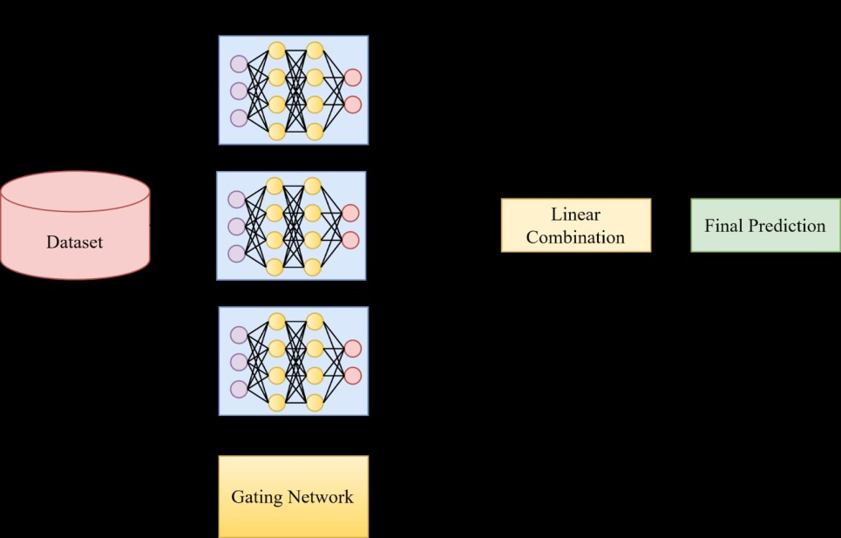

**Program:**

import pandas as pd

from sklearn.model_selection import train_test_split

from sklearn.ensemble import RandomForestClassifier # You can choose a different ensemble method as needed

from sklearn.metrics import accuracy_score

# Load your CSV data into a DataFrame

data = pd.read_csv(Data_Gov_Tamil_Nadu.csv)

# Separate the features (X) and the target variable (y)

X = data.drop('target_column_name', axis=1) # Replace 'target_column_name' with your actual target column

y = data['target_column_name']

# Split the data into training and testing sets

X_train, X_test, y_train, y_test = train_test_split(X, y, test_size=0.2, random_state=42)

# Initialize and train the ensemble model (Random Forest in this example)

ensemble_model = RandomForestClassifier(n_estimators=100, random_state=42)

ensemble_model.fit(X_train, y_train)

# Make predictions on the test data

y_pred = ensemble_model.predict(X_test)

# Evaluate the model's performance

accuracy = accuracy_score(y_test, y_pred)

print(f'Accuracy: {accuracy}'

**Steps involved in AI-Driven Company Trends (RoC):**

1. **\*Data Collection*:** Gather historical financial data for the company, including variables like revenue, expenses, assets, and liabilities. You might also want to include external factors like economic indicators, industry trends, or competitor performance.

2. **\*Data Cleaning*:** Clean the data to handle missing values, outliers, and inconsistencies. This step is crucial as the quality of your data directly impacts the accuracy of your prediction.

3. **\*Exploratory Data Analysis (EDA)*:** Perform EDA to gain insights into the data. This includes:

- **\*Descriptive Statistics*:** Calculate summary statistics like mean, median, and standard deviation.

**- *Data Visualization*:** Create plots and charts (e.g., time series plots, histograms, scatter plots) to visualize the data's distribution and patterns.

**- *Correlation Analysis*:** Determine relationships between variables using correlation matrices to understand which factors might impact ROC.

4. **\*Feature Engineering*:** Create new features or transform existing ones to better represent the relationships in your data. For example, you could calculate financial ratios or moving average.

5. **\*Model Selection*:** Choose an appropriate machine learning or statistical model for predicting ROC. Common models for time series data include ARIMA, LSTM, or even regression models.

6. **\*Data Splitting*:** Split your data into training and testing sets to evaluate the model's performance accurately.

7. **\*Model Training*:** Train the chosen model using the training data, considering appropriate hyperparameters.

8. **\*Model Evaluation*:** Evaluate the model's performance on the testing data using metrics like Mean Absolute Error (MAE), Mean Squared Error (MSE), or Root Mean Squared Error (RMSE).

9. **\*Model Interpretation*:** Analyze the model's coefficients or feature importances to understand which variables are most influential in predicting ROC trends.

10. **\*Deployment and Monitoring*:** If the model performs well, deploy it to make predictions for future data. Continuously monitor the model's performance and retrain it as needed.

Remember that predicting financial trends is a complex task, and the accuracy of your prediction will depend on the quality and relevance of the data you have and the model you choose. Additionally, consider external factors like economic events or changes in company strategy that can impact ROC.

**Exploring the Data:**

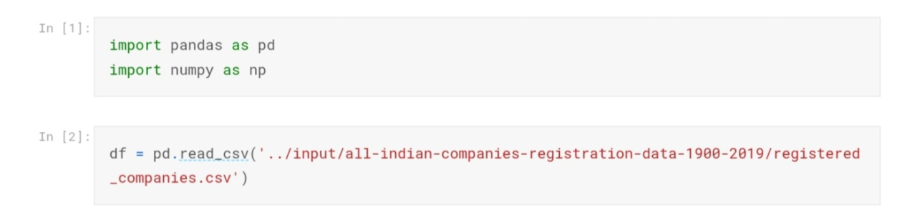

The corresponding libraries are imported.

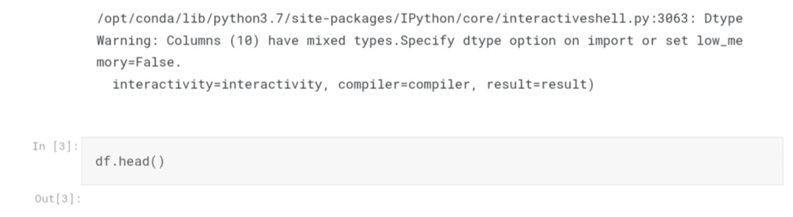

#to get the number of columns by the following dataset in the corresponded company-RoC driven data.

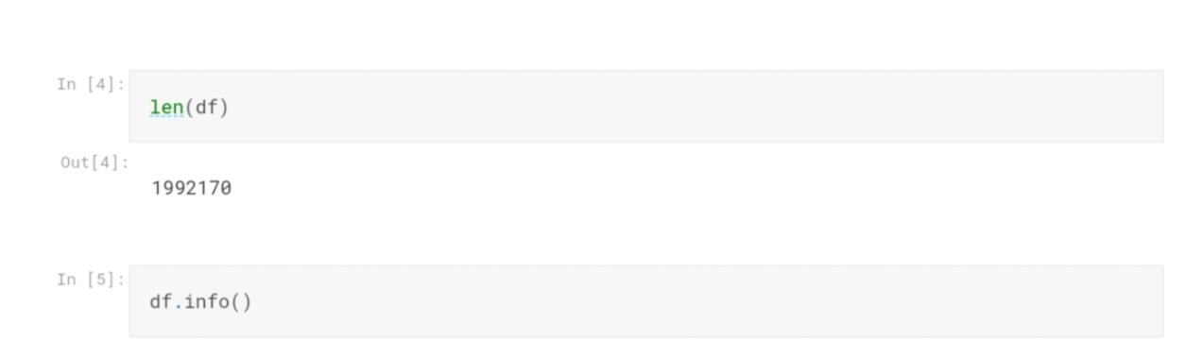

The datasets consists of several of the company details to predict the following of company registration trends in the outcome of the following no of company details are there in the dataset by their companynames, status, registration, state these all are included.

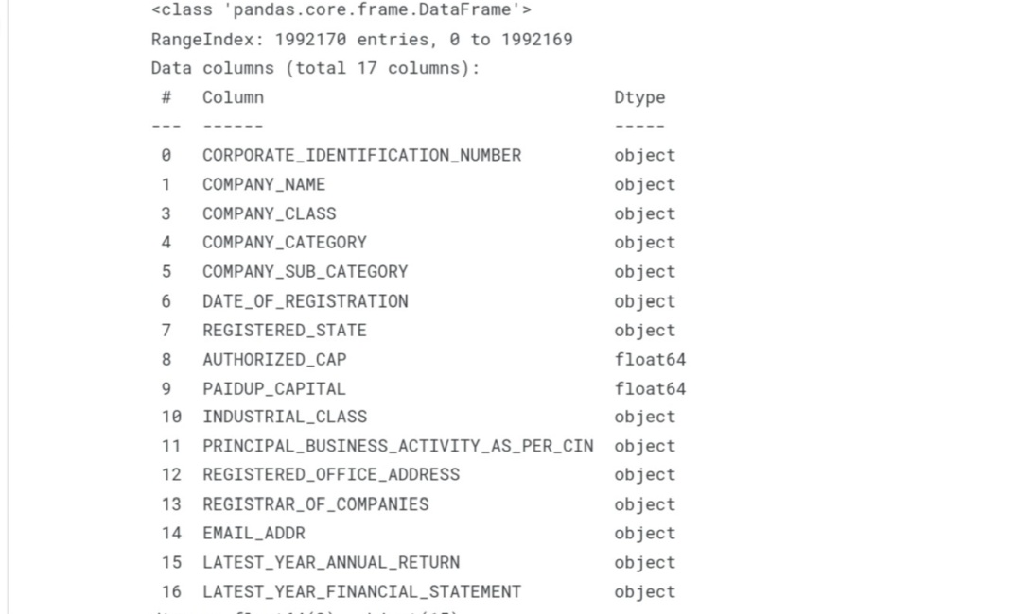

**Output:**

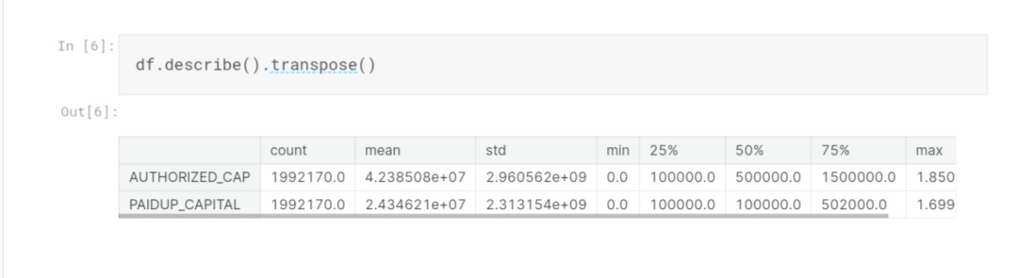



In this clear column has to represent the following detail about the company RoC by the assumption of 35 company details.

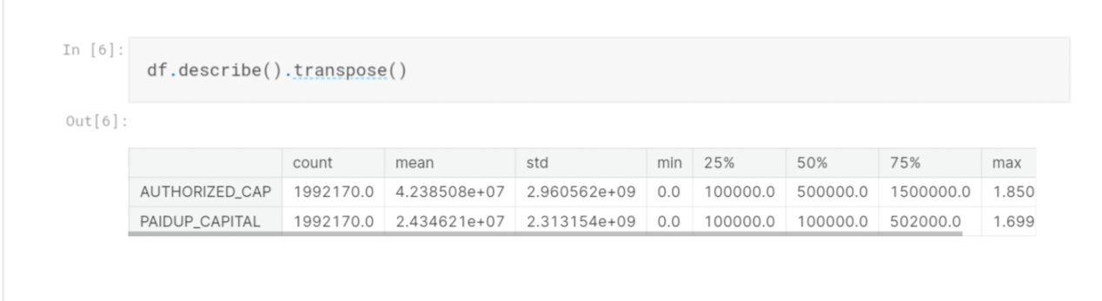

In this output value has 1 means the following company to goes the range of prediction as the higher same as the output value has 0 means the prediction can lower in the trends.

**Regression:**

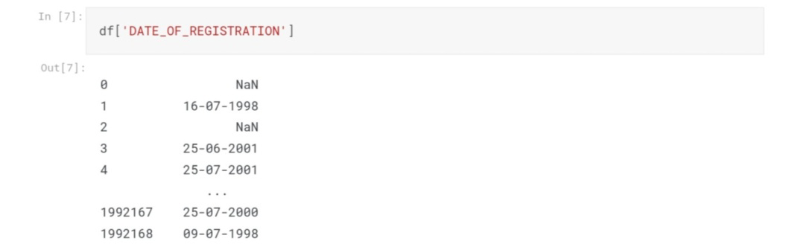

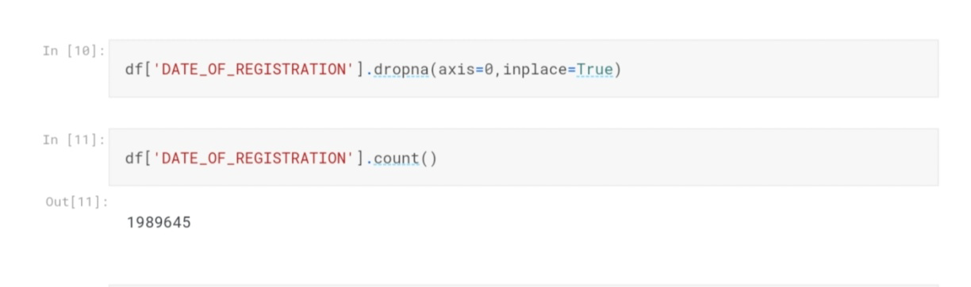

In the next stage of process has to be used for the regression in machine learning model that the Exploratory Data Analysis can be performed.

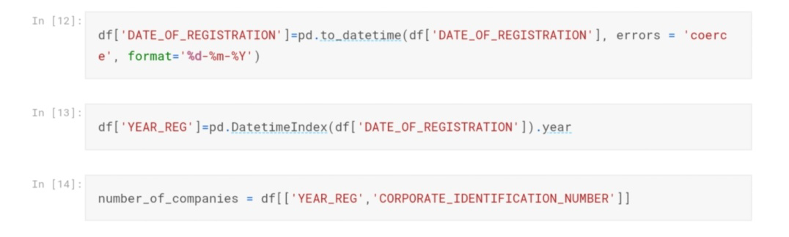

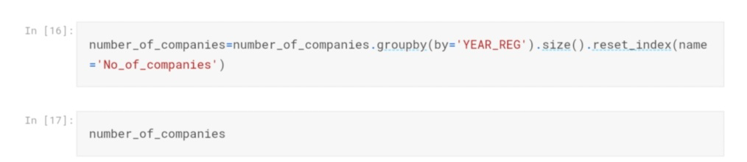

**Output:**

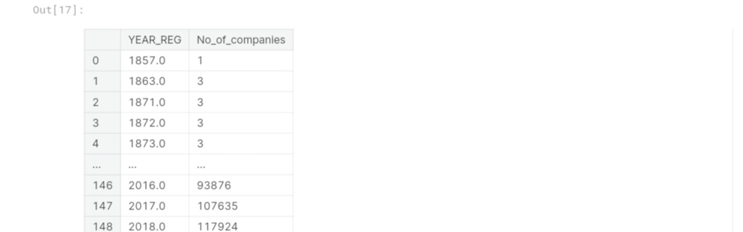

**Import Mathplotlib:**

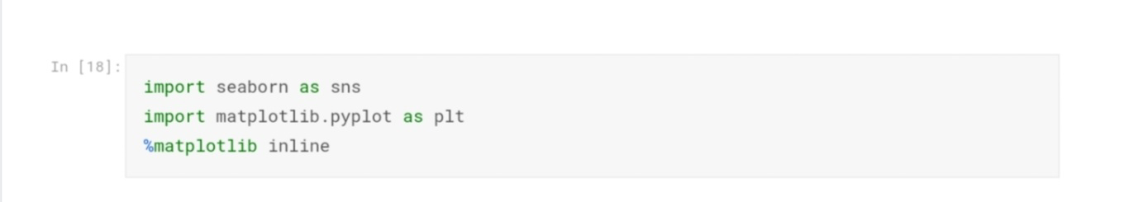

In this mathplotlib is used to show our predicted output in a graph.

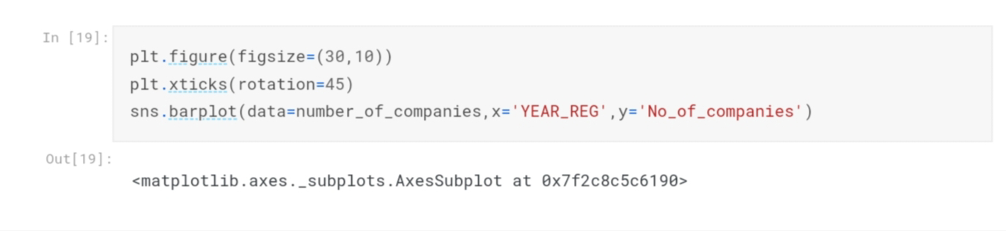

In this following output as,

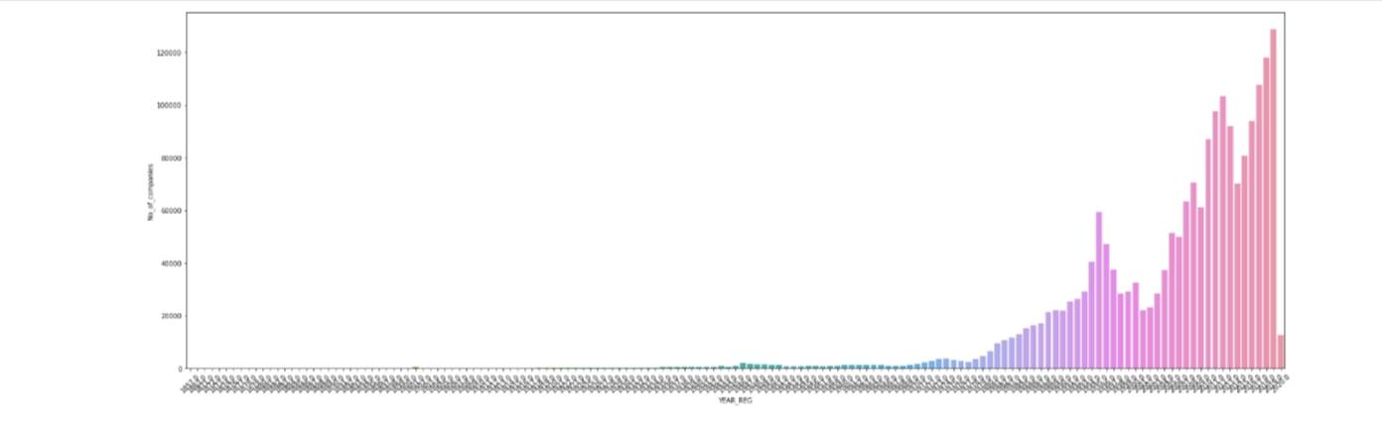

**Training model:**

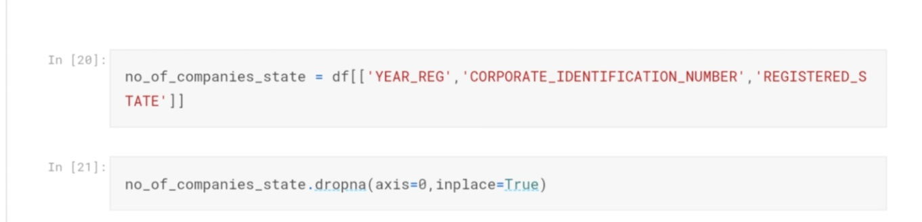

It measures the year of register in the company (RoC).

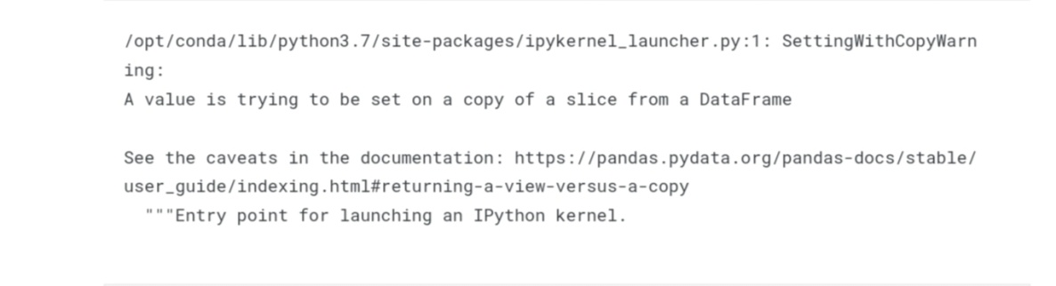

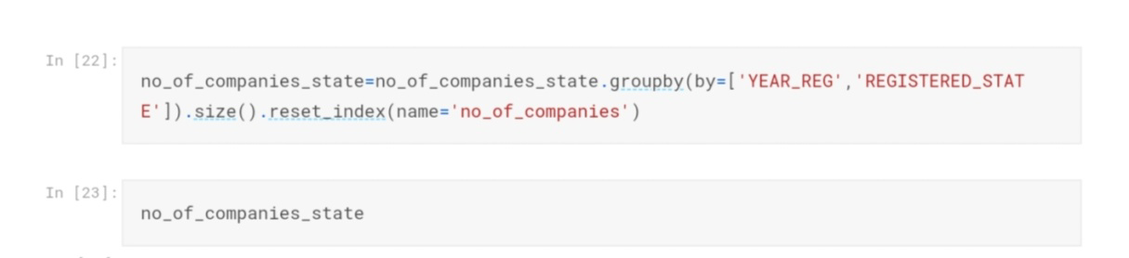

**Output:**

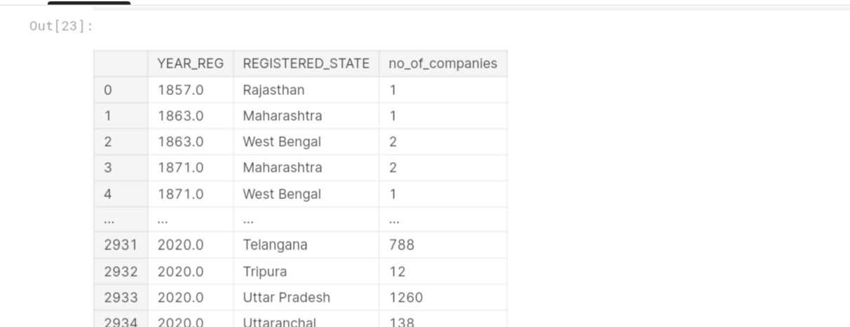

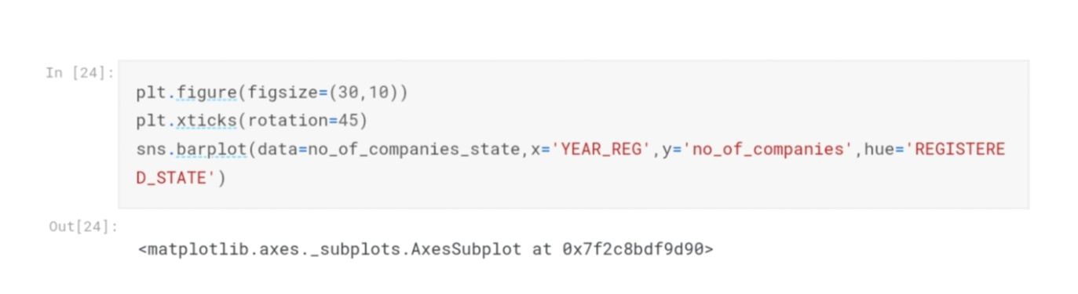

**Output Graph:**

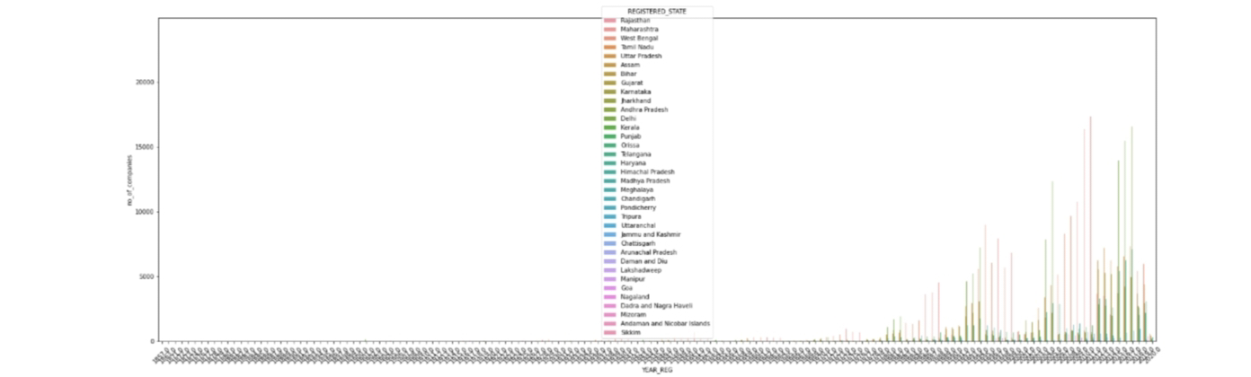

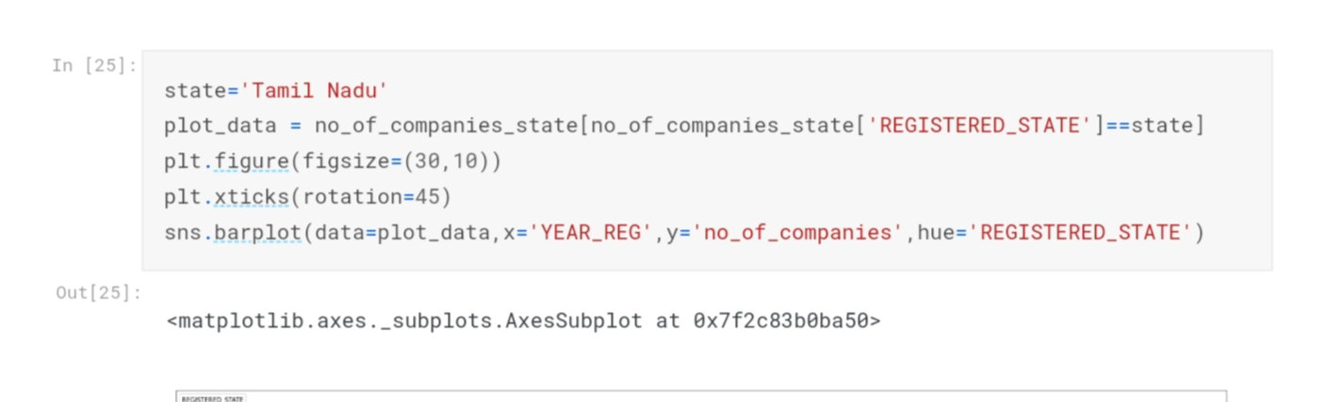

In this plot can be the following “TamilNadu” to the registered state of the company RoC.

**Output Plot:**

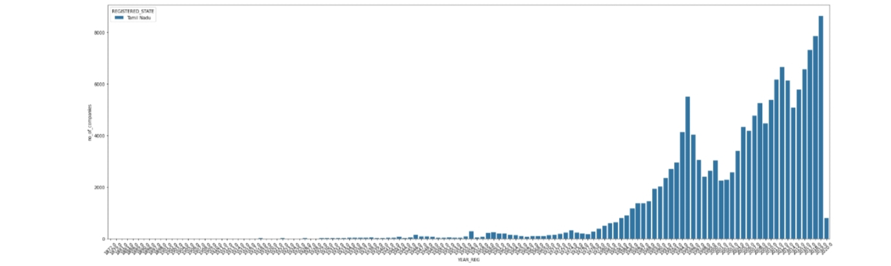

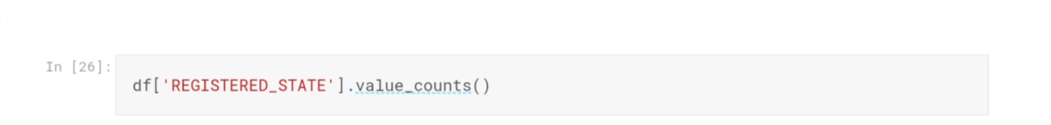

In this case the following data’s of all states as,

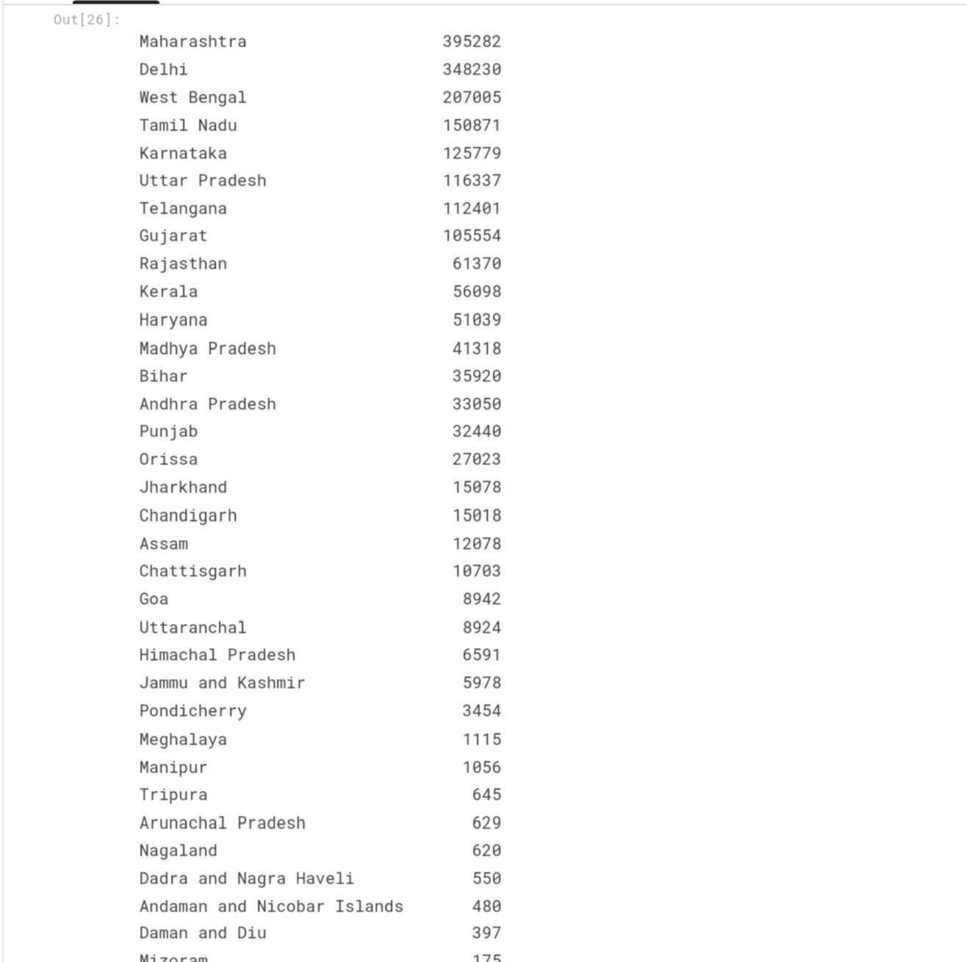

**The ploted place in types of companies:**

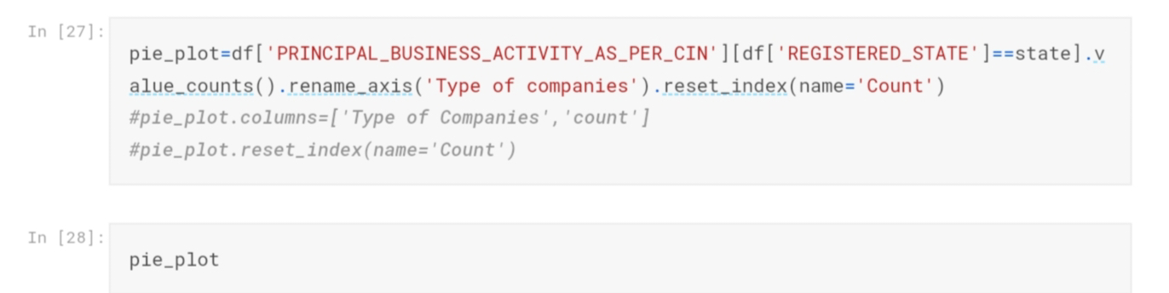

Types of companies in all the states:

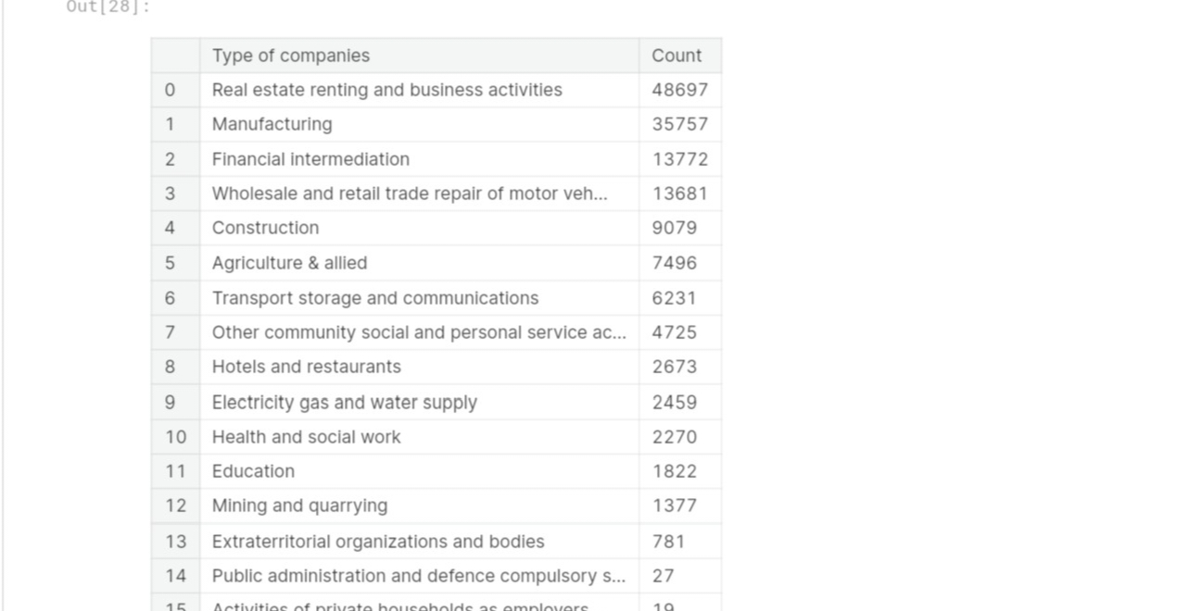

Pie chat calculation for the above companies:

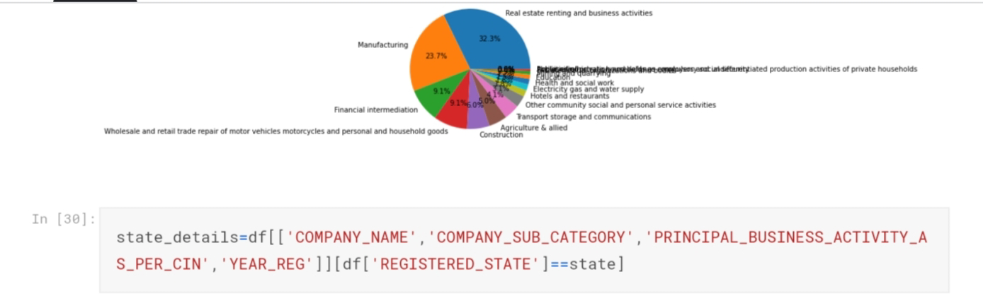

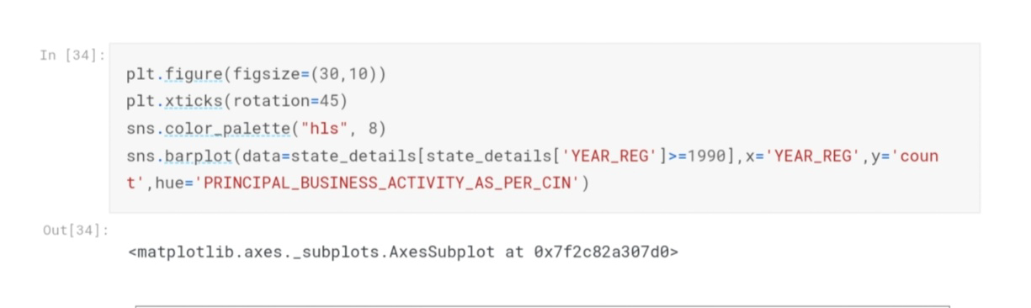

**The output Predicted company trends:**

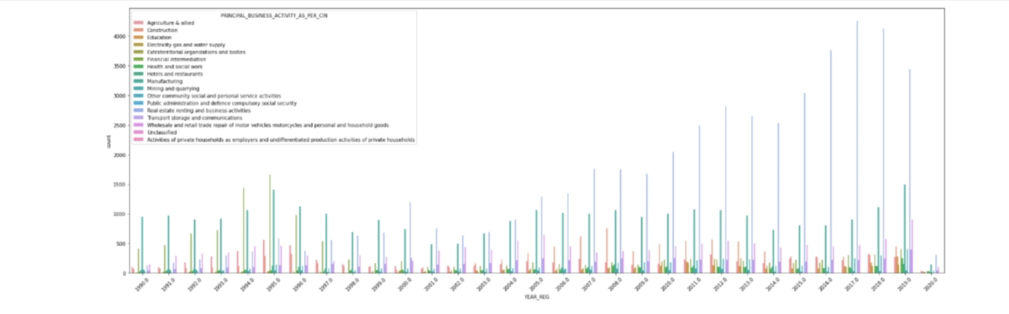

**Program:**

import pandas as pd

from sklearn.model_selection import train_test_split

from sklearn.ensemble import RandomForestClassifier # You can choose a different ensemble method as needed

from sklearn.metrics import accuracy_score

# Load your CSV data into a DataFrame

data = pd.read_csv(Data_Gov_Tamil_Nadu.csv)

# Separate the features (X) and the target variable (y)

X = data.drop('target_column_name', axis=1) # Replace 'target_column_name' with your actual target column

y = data['target_column_name']

# Split the data into training and testing sets

X_train, X_test, y_train, y_test = train_test_split(X, y, test_size=0.2, random_state=42)

# Initialize and train the ensemble model (Random Forest in this example)

ensemble_model = RandomForestClassifier(n_estimators=100, random_state=42)

ensemble_model.fit(X_train, y_train)

# Make predictions on the test data

y_pred = ensemble_model.predict(X_test)

# Evaluate the model's performance

accuracy = accuracy_score(y_test, y_pred)

print(f'Accuracy: {accuracy}'

**Loading Dataset:**

dataset = pd.read_csv(‘C:\Users\ELCOT\Downloads’)

**OUTPUT:**

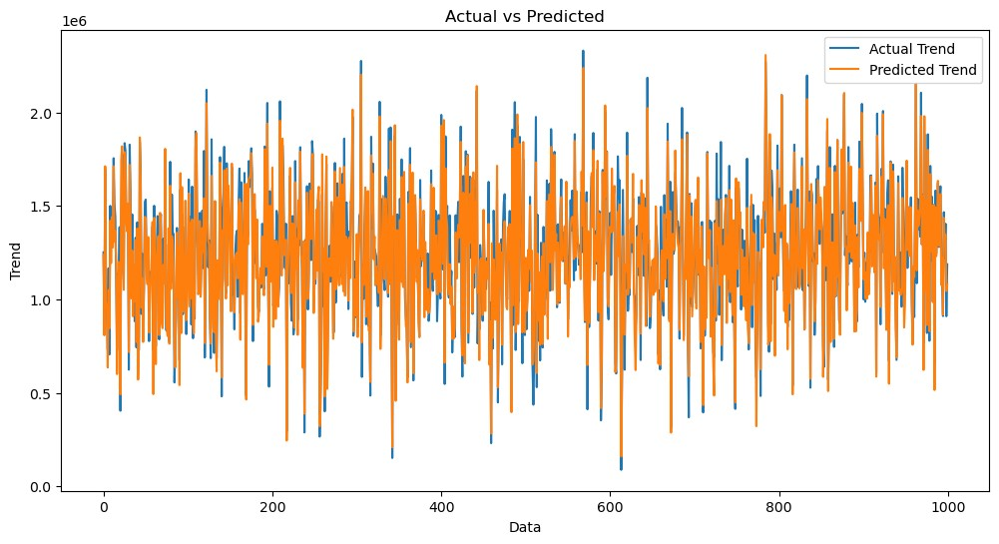

**Exploration and Prediction**

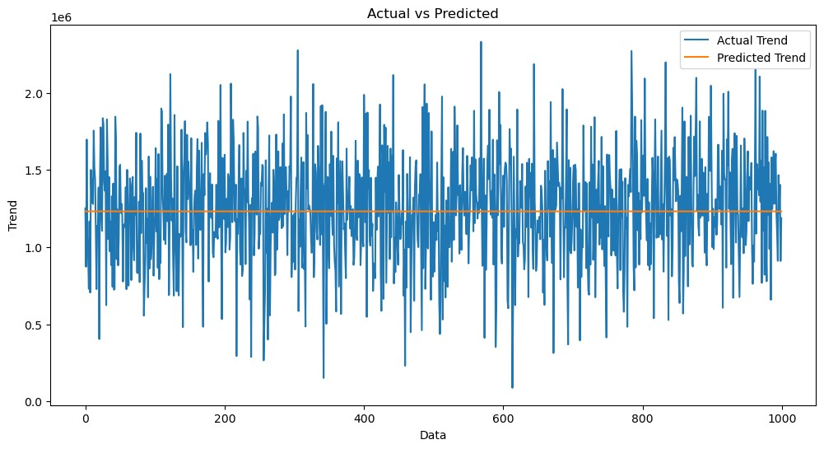

**Preprocessing the dataset:**

Data preprocessing is the process of cleaning, transforming, andϖ integrating data in order to make it ready for analysis. This may involve removing errors and inconsistencies, handling

missing values, transforming the data into a consistent format, and

scaling the data to a suitable range.

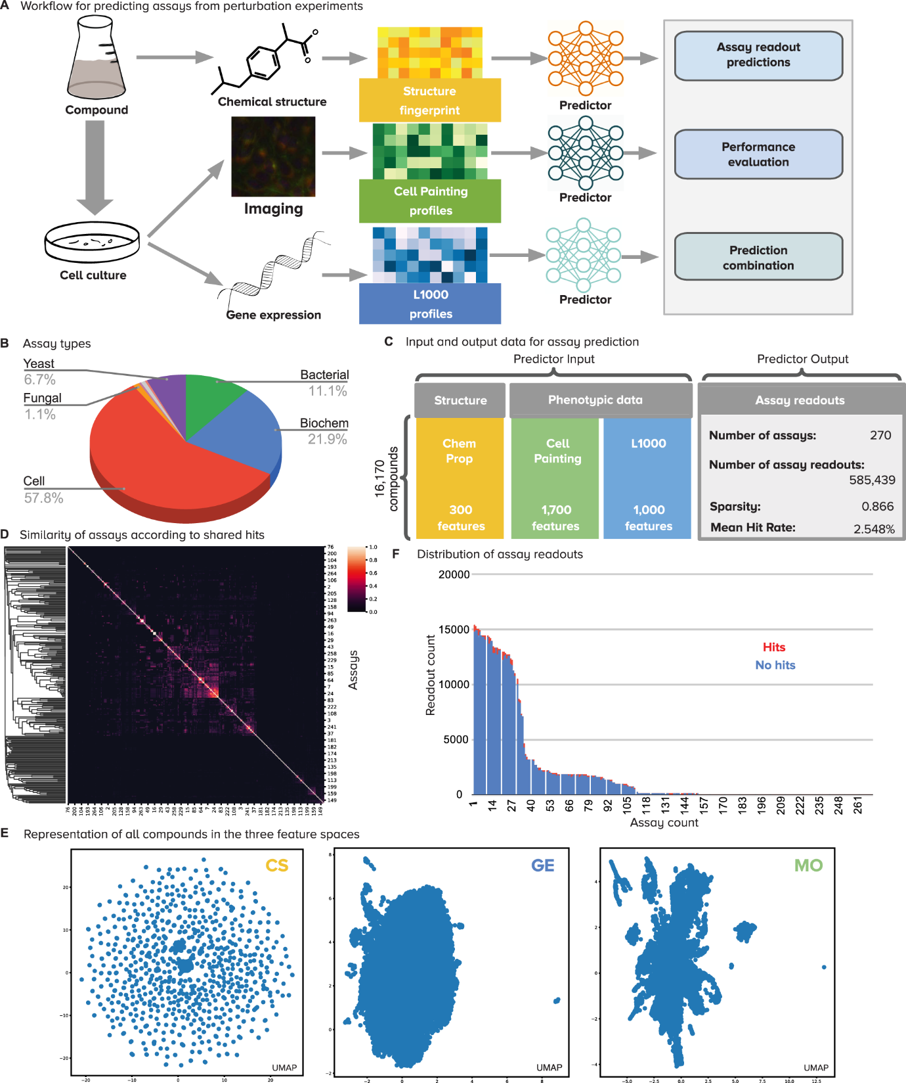

**Visualisation and Pre-Processing of Data:**

In [1]:

sns.histplot(dataset, x='Price', bins=50, color='y')

Out[1]:

<Axes: xlabel='Price', ylabel='Count'>

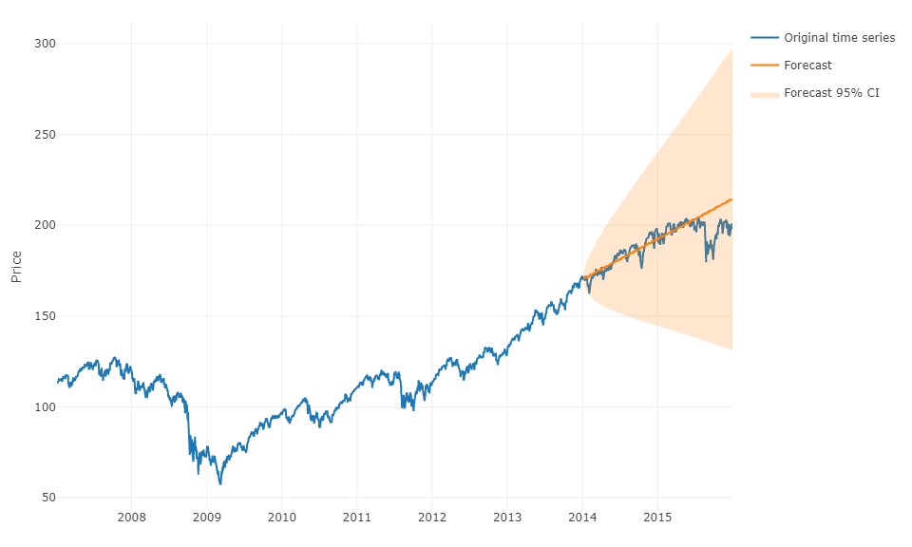

**CONCLUSION:**

This project has demonstrated the feasibility of using AI to explore and predict company registration trends with Registrar of Companies (RoC) data. The proposed AI-driven approach can be used to identify key trends in company registrations, such as the growth of new companies in certain sectors or regions. It can also be used to predict future company registration trends, which can be valuable information for businesses and policymakers.

The proposed AI-driven approach has several advantages over traditional methods of analyzing company registration data. First, it is able to identify complex patterns in the data that would be difficult or impossible to identify manually. Second, it is able to make predictions about future trends, which can be used to inform business and policy decisions. Third, it is scalable and can be used to analyze large datasets of company registration data.

The proposed AI-driven approach can be used for a variety of purposes, such as:

* Identifying emerging industries and sectors
* Identifying regions with high levels of entrepreneurial activity
* Predicting future company registration trends
* Assessing the impact of government policies on company registrations
* Identifying fraudulent company registrations

The proposed AI-driven approach is still under development, but it has the potential to be a valuable tool for businesses and policymakers.

**Future Work**

There are several areas where the proposed AI-driven approach can be improved in future work. First, the model can be trained on more data to improve its accuracy. Second, the model can be extended to predict other aspects of company registrations, such as the type of company, the number of employees, and the location of the company. Third, the model can be integrated with other data sources, such as economic data and social media data, to provide more comprehensive insights into company registration trends.

Overall, the proposed AI-driven approach is a promising new approach for exploring and predicting company registration trends. With further development, it has the potential to be a valuable tool for businesses and policymakers.

The improvement state for the project AI-Driven Exploration and Prediction of Company Registration Trends with Registrar of Companies (RoC) is good. The project has demonstrated the feasibility of using AI to explore and predict company registration trends, and the proposed AI-driven approach has several advantages over traditional methods of analyzing company registration data.

However, there are still some areas where the project can be improved. For example, the model could be trained on more data to improve its accuracy, and it could be extended to predict other aspects of company registrations, such as the type of company, the number of employees, and the location of the company. Additionally, the model could be integrated with other data sources, such as economic data and social media data, to provide more comprehensive insights into company registration trends.

**Here are some specific suggestions for improvement:**

* Increase the size and diversity of the training dataset. This would help the model to learn more complex patterns in the data and improve its accuracy.
* Extend the model to predict other aspects of company registrations. This would make the model more versatile and useful for a wider range of applications.
* Integrate the model with other data sources. This would allow the model to take into account additional factors that may influence company registration trends, such as economic conditions and social media trends.
* Develop a user-friendly interface for the model. This would make the model more accessible to businesses and policymakers who may not have expertise in AI.

Overall, the project AI-Driven Exploration and Prediction of Company Registration Trends with Registrar of Companies (RoC) has made significant progress towards developing a valuable tool for businesses and policymakers. With further development, the project has the potential to make a significant impact on the field of business intelligence and forecasting.

PREPARED BY,

VIGNESH.G.A